Persist data with Room

1. Before you begin
Most production-quality apps have data that the app needs to persist. For example, the app might store a playlist of songs, items on a to-do list, records of expenses and income, a catalog of constellations, or a history of personal data. For such use cases, you use a database to store this persistent data.
Room (https://developer.android.com/topic/libraries/architecture/room) is a persistence library that's part of Android Jetpack (https://developer.android.com/jetpack/androidx/explorer?case=data). Room is an abstraction layer on top of a SQLite (https://developer.android.com/training/data-storage/sqlite) database. SQLite uses a specialized language (SQL) to perform database operations. Instead of using SQLite directly, Room simplifies the chores of database setup, configuration, and interactions with the app. Room also provides compile-time checks of SQLite statements.
An abstraction layer is a set of functions that hide the underlying implementation/complexity. It provides an interface to an existing set of functionality, like SQLite in this case.
The image below shows how Room, as a data source, fits in with the overall architecture recommended in this course. Room is a Data Source.
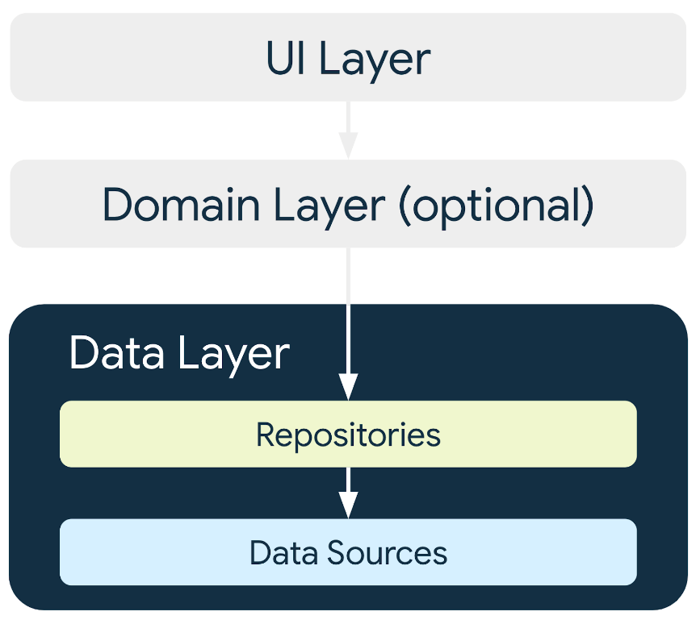

Prerequisites
- Ability to build a basic user interface (UI) for an Android app using Jetpack Compose.
- Ability to use composables like Text, Icon, IconButton, and LazyColumn.
- Ability to use the NavHost composable to define routes and screens in your app.
- Ability to navigate between screens using a NavHostController.
- Familiarity with the Android architecture component ViewModel. Ability to use ViewModelProvider.Factory to instantiate the ViewModels.
- Familiarity with concurrency fundamentals.
- Ability to use coroutines for long-running tasks.
- Basic knowledge of SQLite databases and the SQL language.

What you'll learn
- How to create and interact with the SQLite database using the Room library.
- How to create an entity, a data access object (DAO), and database classes.
- How to use a DAO to map Kotlin functions to SQL queries.

What you'll build
- You'll build an Inventory app that saves inventory items into the SQLite database.

What you need
- Starter code for the Inventory app
- A computer with Android Studio
- Device or an emulator with API level 26 or higher

2. App overview
In this codelab, you work with a starter code of the Inventory app and add the database layer to it using the Room library. The final version of the app displays a list of items from the inventory database. The user has options to add a new item, update an existing item, and delete an item from the inventory database. For this codelab, you save the item data to the Room database. You complete the rest of the app's functionality in the next codelab.
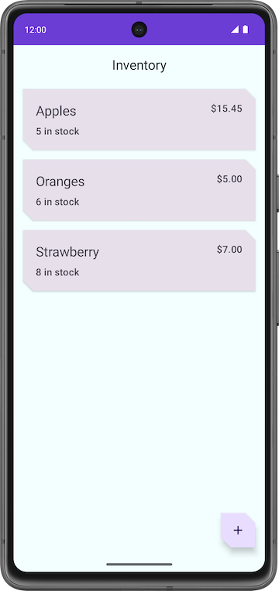 | 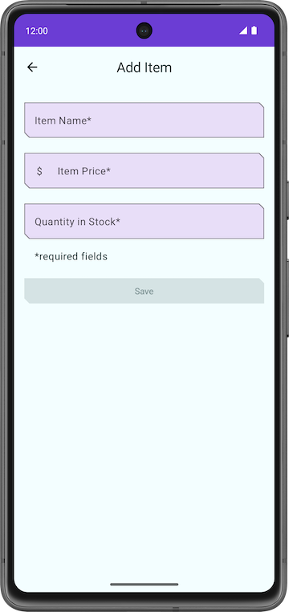 | 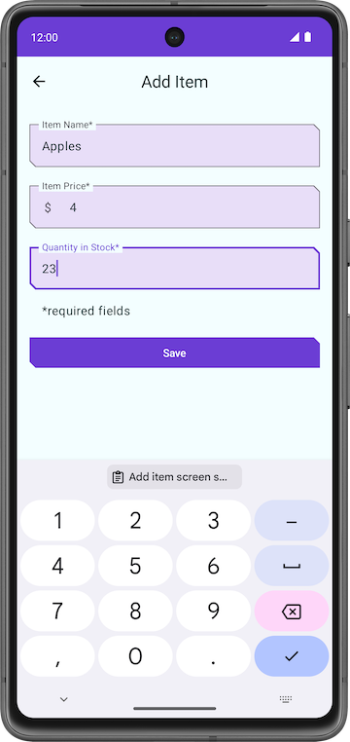

Note: The above screenshots are from the final version of the app at the end of the pathway, not the end of this codelab. These screenshots give you an idea of the final version of the app.

3. Starter app overview
Download the starter code for this codelab
To get started, download the starter code:
https://github.com/google-developer-training/basic-android-kotlin-compose-training-inventory-app/archive/refs/heads/starter.zip
Alternatively, you can clone the GitHub repository for the code:
$ git clone https://github.com/google-developer-training/basic-android-kotlin-compose-training-inventory-app.git
$ cd basic-android-kotlin-compose-training-inventory-app
$ git checkout starter

Note: The starter code is in the starter branch of the downloaded repository.
You can browse the code in the Inventory app GitHub repository (https://github.com/google-developer-training/basic-android-kotlin-compose-training-inventory-app/tree/starter).

Starter code overview
- Open the project with the starter code in Android Studio.
- Run the app on an Android device or an emulator. Make sure the emulator or connected device runs with an API level 26 or higher. Database Inspector (https://developer.android.com/studio/inspect/database) works on emulators/devices that run API level 26 and higher.
Note: The Database Inspector lets you inspect, query, and modify your app's databases while your app runs. The Database Inspector works with plain SQLite or with libraries built on top of SQLite, such as Room.
- Notice that the app shows no inventory data.
- Tap the floating action button (FAB), which lets you add new items to the database.
The app navigates to a new screen where you can enter details for the new item.
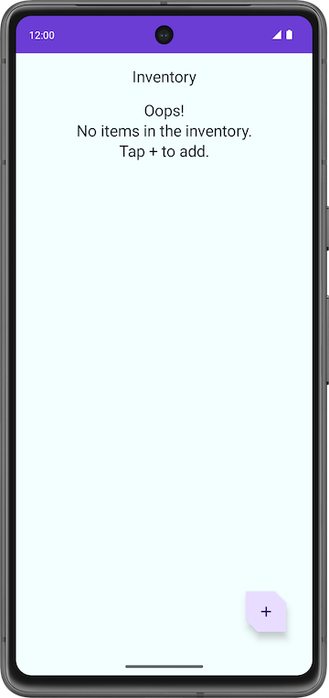

Problems with the starter code
- In the Add Item screen, enter an item's details like name, price, and quantity of the Item.
- Tap Save. The Add Item screen is not closed, but you can navigate back using the back key. The save functionality is not implemented, so the item details are not saved.
Notice that the app is incomplete and the Save button functionality is not implemented.
In this codelab, you add the code that uses Room to save the inventory details in the SQLite database. You use the Room persistence library to interact with the SQLite database.

Code walkthrough
The starter code you downloaded has pre-designed screen layouts for you. In this pathway, you focus on implementing the database logic. The following section is a brief walkthrough of some of the files to get you started.

ui/home/HomeScreen.kt
This file is the home screen, or the first screen in the app, which contains the composables to display the inventory list. It has a FAB  to add new items to the list. You display the items in the list later in the pathway.

ui/item/ItemEntryScreen.kt
This screen is similar to ItemEditScreen.kt. They both have text fields for the item details. This screen is displayed when the FAB is tapped in the home screen. The ItemEntryViewModel.kt is the corresponding ViewModel for this screen.
ui/navigation/InventoryNavGraph.kt
This file is the navigation graph for the entire application.

4. Main components of Room
Kotlin provides an easy way to work with data through data classes. While it is easy to work with in-memory data using data classes, when it comes to persisting data, you need to convert this data into a format compatible with database storage. To do so, you need tables to store the data and queries to access and modify the data.
The following three components of Room (https://developer.android.com/topic/libraries/architecture/room) make these workflows seamless.
- Room entities (https://developer.android.com/training/data-storage/room/defining-data) represent tables in your app's database. You use them to update the data stored in rows in tables and to create new rows for insertion.
- Room DAOs (https://developer.android.com/training/data-storage/room/accessing-data) provide methods that your app uses to retrieve, update, insert, and delete data in the database.
- Room Database class (https://developer.android.com/reference/kotlin/androidx/room/Database) is the database class that provides your app with instances of the DAOs associated with that database.
You implement and learn more about these components later in the codelab. The following diagram demonstrates how the components of Room work together to interact with the database.
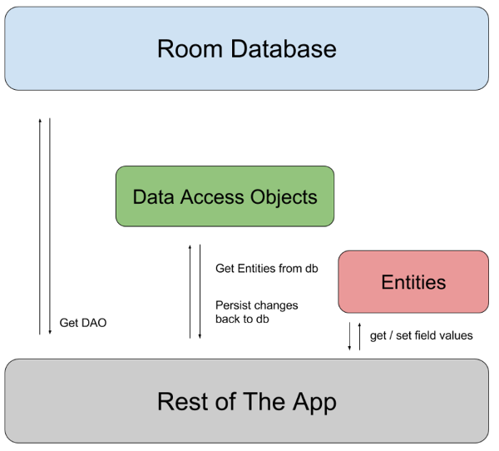

Add Room dependencies
In this task, you add the required Room component libraries to your Gradle files.
- Open the module-level gradle file build.gradle.kts (Module: InventoryApp.app).
- In the dependencies block, add the dependencies for the Room library shown in the following code.
//Room
implementation("androidx.room:room-runtime:${rootProject.extra["room_version"]}")
ksp("androidx.room:room-compiler:${rootProject.extra["room_version"]}")
implementation("androidx.room:room-ktx:${rootProject.extra["room_version"]}")

KSP is a powerful and yet simple API for parsing Kotlin annotations.
Note: For the library dependencies in your Gradle file, always use the most current stable release version numbers from the AndroidX releases (https://developer.android.com/jetpack/androidx/versions) page.

5. Create an item Entity
An Entity (https://developer.android.com/reference/androidx/room/Entity) class defines a table, and each instance of this class represents a row in the database table. The entity class has mappings to tell Room how it intends to present and interact with the information in the database. In your app, the entity holds information about inventory items, such as item name, item price, and quantity of items available.
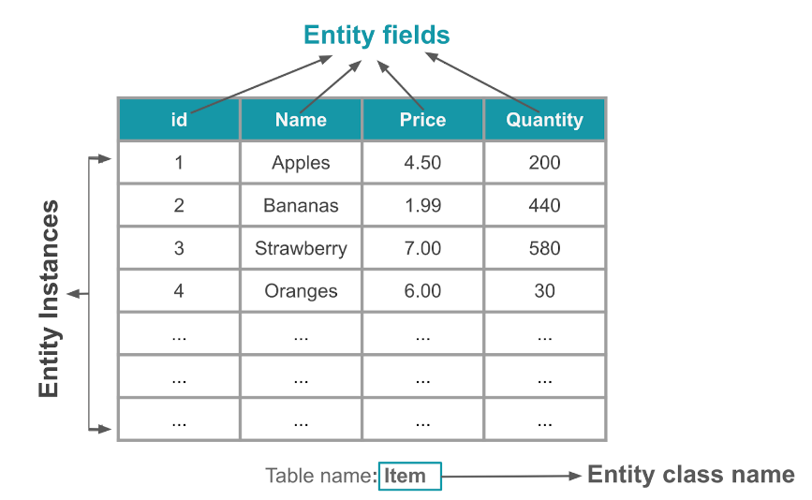
The @Entity annotation marks a class as a database Entity class. For each Entity class, the app creates a database table to hold the items. Each field of the Entity is represented as a column in the database, unless denoted otherwise (see Entity docs for details). Every entity instance stored in the database must have a primary key. The primary key (https://developer.android.com/reference/androidx/room/PrimaryKey) is used to uniquely identify every record/entry in your database tables. After the app assigns a primary key, it cannot be modified; it represents the entity object as long as it exists in the database.
In this task, you create an Entity class and define fields to store the following inventory information for each item: an Int to store the primary key, a String to store the item name, a double to store the item price, and an Int to store the quantity in stock.
- Open the starter code in the Android Studio.
- Open the data package under the com.example.inventory base package.
- Inside the data package, open the Item Kotlin class, which represents a database entity in your app.
// No need to copy over, this is part of the starter code
class Item(
val id: Int,
val name: String,
val price: Double,
val quantity: Int
)

Note: As a reminder, the primary constructor is part of the class header in a Kotlin class. It goes after the class name (and optional type parameters).

Data classes
Data classes are primarily used to hold data in Kotlin. They are defined with the keyword data. Kotlin data class objects have some extra benefits. For example, the compiler automatically generates utilities to compare, print, and copy such as toString(), copy(), and equals().

Example:
// Example data class with 2 properties.
data class User(val firstName: String, val lastName: String){
}

To ensure consistency and meaningful behavior of the generated code, data classes must fulfill the following requirements:
- The primary constructor must have at least one parameter.
- All primary constructor parameters must be val or var.
- Data classes cannot be abstract, open, or sealed.
Warning: The compiler only uses the properties defined inside the primary constructor for the automatically generated functions. The compiler excludes properties declared inside the class body from the generated implementations.
To learn more about Data classes, check out the Data classes (https://kotlinlang.org/docs/data-classes.html) documentation.
- Prefix the definition of the Item class with the data keyword to convert it to a data class.
data class Item(
val id: Int,
val name: String,
val price: Double,
val quantity: Int
)

- Above the Item class declaration, annotate the data class with @Entity. Use the tableName argument to set the items as the SQLite table name.
import androidx.room.Entity
@Entity(tableName = "items")
data class Item(
...
)

Note: The @Entity annotation has several possible arguments. By default (no arguments to @Entity), the table name is the same as the class name. Use the tableName argument to customize the table name. For simplicity, you use an item. There are several other arguments for @Entity you can investigate in the Entity documentation (https://developer.android.com/reference/androidx/room/Entity).
- Annotate the id property with @PrimaryKey to make the id the primary key. A primary key is an ID to uniquely identify every record/entry in your Item table
import androidx.room.PrimaryKey
@Entity(tableName = "items")
data class Item(
@PrimaryKey
val id: Int,
...
)

- Assign the id a default value of 0, which is necessary for the id to auto generate id values.
- Add the autoGenerate parameter to the @PrimaryKey annotation to specify whether the primary key column should be auto-generated. If autogenerate is set to true, Room will automatically generate a unique value for the primary key column when a new entity instance is inserted into the database. This ensures that each entity instance has a unique identifier, without having to manually assign values to the primary key column
data class Item(
@PrimaryKey(autoGenerate = true)
val id: Int = 0,
// ...
)

Great! Now that you have created an Entity class, you can create a Data Access Object (DAO) to access the database.
6. Create the item DAO
The Data Access Object (https://developer.android.com/reference/androidx/room/Dao) (DAO) is a pattern you can use to separate the persistence layer from the rest of the application by providing an abstract interface. This isolation follows the single-responsibility principle (https://en.wikipedia.org/wiki/Single-responsibility_principle), which you have seen in previous codelabs.
The functionality of the DAO is to hide all the complexities involved in performing database operations in the underlying persistence layer, separate from the rest of the application. This lets you change the data layer independently of the code that uses the data.
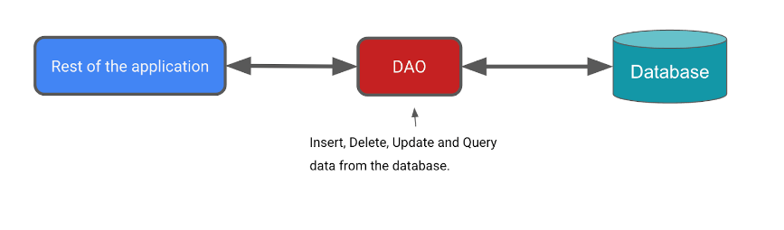
In this task, you define a DAO for Room. DAOs are the main components of Room that are responsible for defining the interface that accesses the database.
The DAO you create is a custom interface that provides convenience methods for querying/retrieving, inserting, deleting, and updating the database. Room generates an implementation of this class at compile time.
The Room library provides convenience annotations, such as @Insert, @Delete, and @Update, for defining methods that perform simple inserts, deletes, and updates without requiring you to write a SQL statement.
If you need to define more complex operations for insert, delete, update, or if you need to query the data in the database, use a @Query annotation instead.
As an added bonus, as you write your queries in Android Studio, the compiler checks your SQL queries for syntax errors.
For the Inventory app, you need the ability to do the following:
- Insert or add a new item.
- Update an existing item to update the name, price, and quantity.
- Get a specific item based on its primary key, id.
- Get all items so you can display them.
- Delete an entry in the database.
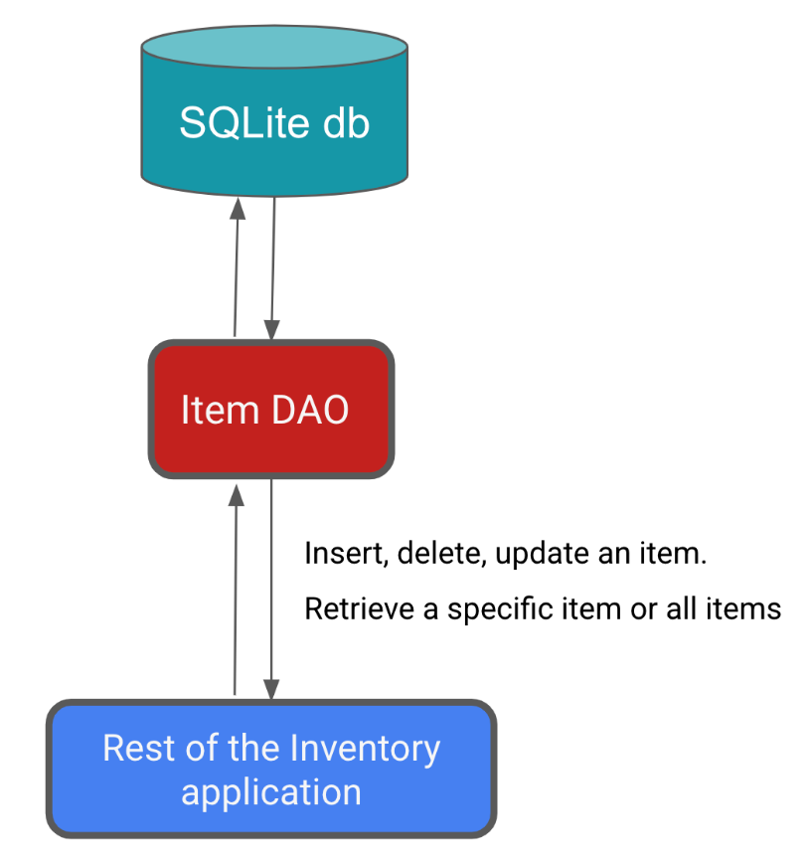
Complete the following steps to implement the item DAO in your app:
- In the data package, create the Kotlin interface ItemDao.kt.
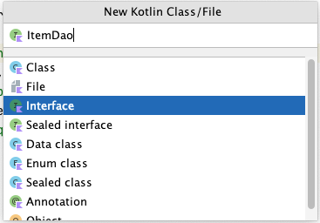
- Annotate the ItemDao interface with @Dao.
import androidx.room.Dao
@Dao
interface ItemDao {
}

- Inside the body of the interface, add an @Insert annotation.
- Below the @Insert, add an insert() function that takes an instance of the Entity class item as its argument.
- Mark the function with the suspend keyword to let it run on a separate thread.
The database operations can take a long time to execute, so they need to run on a separate thread. Room doesn't allow database access on the main thread.
import androidx.room.Insert
@Insert
suspend fun insert(item: Item)

When inserting items into the database, conflicts can happen. For example, multiple places in the code tries to update the entity with different, conflicting, values such as the same primary key. An entity is a row in DB. In the Inventory app, we only insert the entity from one place that is the Add Item screen so we are not expecting any conflicts and can set the conflict strategy to Ignore.
- Add an argument onConflict and assign it a value of OnConflictStrategy.IGNORE.
The argument onConflict tells the Room what to do in case of a conflict. The OnConflictStrategy.IGNORE strategy ignores a new item.
To know more about the available conflict strategies, check out the OnConflictStrategy (https://developer.android.com/reference/androidx/room/OnConflictStrategy.html) documentation.
import androidx.room.OnConflictStrategy
@Insert(onConflict = OnConflictStrategy.IGNORE)
suspend fun insert(item: Item)

Now Room generates all the necessary code to insert the item into the database. When you call any of the DAO functions that are marked with Room annotations, Room executes the corresponding SQL query on the database. For example, when you call the above method, insert() from your Kotlin code, Room executes a SQL query to insert the entity into the database.
- Add a new function with @Update annotation that takes an Item as parameter.
The entity that's updated has the same primary key as the entity that's passed in. You can update some or all of the entity's other properties.
- Similar to the insert() method, mark this function with the suspend keyword.
import androidx.room.Update
@Update
suspend fun update(item: Item)

Add another function with the @Delete annotation to delete item(s), and make it a suspending function.
Note: The @Delete annotation deletes an item or a list of items. You need to pass the entities you want to delete. If you don't have the entity, you might have to fetch it before calling the delete() function.
import androidx.room.Delete
@Delete
suspend fun delete(item: Item)

There is no convenience annotation for the remaining functionality, so you have to use the @Query annotation and supply SQLite queries.
- Write a SQLite query to retrieve a particular item from the item table based on the given id. The following code provides a sample query that selects all columns from the items, where the id matches a specific value and id is a unique identifier.

Example:
// Example, no need to copy over
SELECT * from items WHERE id = 1

- Add a @Query annotation.
- Use the SQLite query from the previous step as a string parameter to the @Query annotation.
- Add a String parameter to the @Query that is a SQLite query to retrieve an item from the item table.
The query now says to select all columns from the items, where the id matches the :id argument. Notice the :id uses the colon notation in the query to reference arguments in the function.
@Query("SELECT * from items WHERE id = :id")

- After the @Query annotation, add a getItem() function that takes an Int argument and returns a Flow<Item>.
import androidx.room.Query
import kotlinx.coroutines.flow.Flow
@Query("SELECT * from items WHERE id = :id")
fun getItem(id: Int): Flow<Item>

It is recommended to use Flow in the persistence layer. With Flow as the return type, you receive notification whenever the data in the database changes. The Room keeps this Flow updated for you, which means you only need to explicitly get the data once. This setup is helpful to update the inventory list, which you implement in the next codelab. Because of the Flow return type, Room also runs the query on the background thread. You don't need to explicitly make it a suspend function and call it inside a coroutine scope.
Note: Flow in Room database can keep the data up-to-date by emitting a notification whenever the data in the database changes. This allows you to observe the data and update your UI accordingly.
- Add a @Query with a getAllItems() function.
- Have the SQLite query return all columns from the item table, ordered in ascending order.
- Have getAllItems() return a list of Item entities as Flow. Room keeps this Flow updated for you, which means you only need to explicitly get the data once.
@Query("SELECT * from items ORDER BY name ASC")
fun getAllItems(): Flow<List<Item>>

Completed ItemDao:
import androidx.room.Dao
import androidx.room.Delete
import androidx.room.Insert
import androidx.room.OnConflictStrategy
import androidx.room.Query
import androidx.room.Update
import kotlinx.coroutines.flow.Flow
@Dao
interface ItemDao {
@Insert(onConflict = OnConflictStrategy.IGNORE)
suspend fun insert(item: Item)
@Update
suspend fun update(item: Item)
@Delete
suspend fun delete(item: Item)
@Query("SELECT * from items WHERE id = :id")
fun getItem(id: Int): Flow<Item>
@Query("SELECT * from items ORDER BY name ASC")
fun getAllItems(): Flow<List<Item>>
}

- Though you won't see any visible changes, build your app to make sure it has no errors.

7. Create a Database instance
In this task, you create a RoomDatabase that uses your Entity and DAO from the previous tasks. The database class defines the list of entities and DAOs.
The Database class provides your app with instances of the DAOs you define. In turn, the app can use the DAOs to retrieve data from the database as instances of the associated data entity objects. The app can also use the defined data entities to update rows from the corresponding tables or to create new rows for insertion.
You need to create an abstract RoomDatabase class and annotate it with @Database. This class has one method that returns the existing instance of the RoomDatabase if the database doesn't exist.
Here's the general process for getting the RoomDatabase instance:
- Create a public abstract class that extends RoomDatabase. The new abstract class you define acts as a database holder. The class you define is abstract because Room creates the implementation for you.
- Annotate the class with @Database. In the arguments, list the entities for the database and set the version number.
- Define an abstract method or property that returns an ItemDao instance, and the Room generates the implementation for you.
- You only need one instance of the RoomDatabase for the whole app, so make the RoomDatabase a singleton.
- Use Room's Room.databaseBuilder to create your (item_database) database only if it doesn't exist. Otherwise, return the existing database.

Create the Database
- In the data package, create a Kotlin class InventoryDatabase.kt.
- In the InventoryDatabase.kt file, make InventoryDatabase class an abstract class that extends RoomDatabase.
- Annotate the class with @Database. Disregard the missing parameters error, which you fix in the next step.
import androidx.room.Database
import androidx.room.RoomDatabase
@Database
abstract class InventoryDatabase : RoomDatabase() {}

The @Database annotation requires several arguments so that Room can build the database.
- Specify the Item as the only class with the list of entities.
- Set the version as 1. Whenever you change the schema of the database table, you have to increase the version number.
- Set exportSchema to false so as not to keep schema version history backups.
@Database(entities = [Item::class], version = 1, exportSchema = false)

- Inside the body of the class, declare an abstract function that returns the ItemDao so that the database knows about the DAO.
abstract fun itemDao(): ItemDao

- Below the abstract function, define a companion object, which allows access to the methods to create or get the database and uses the class name as the qualifier.

companion object {}

- Inside the companion object, declare a private nullable variable Instance for the database and initialize it to null.
The Instance variable keeps a reference to the database, when one has been created. This helps maintain a single instance of the database opened at a given time, which is an expensive resource to create and maintain.
- Annotate Instance with @Volatile.
The value of a volatile variable is never cached, and all reads and writes are to and from the main memory. These features help ensure the value of Instance is always up to date and is the same for all execution threads. It means that changes made by one thread to Instance are immediately visible to all other threads.
@Volatile
private var Instance: InventoryDatabase? = null

- Below Instance, while still inside the companion object, define a getDatabase() method with a Context parameter that the database builder needs.
- Return a type InventoryDatabase. An error message appears because getDatabase() isn't returning anything yet.
import android.content.Context
fun getDatabase(context: Context): InventoryDatabase {}

Multiple threads can potentially ask for a database instance at the same time, which results in two databases instead of one. This issue is known as a race condition (https://en.wikipedia.org/wiki/Race_condition). Wrapping the code to get the database inside a synchronized block means that only one thread of execution at a time can enter this block of code, which makes sure the database only gets initialized once. Use synchronized{} block to avoid the race condition.
- Inside getDatabase(), return the Instance variable—or, if Instance is null, initialize it inside a synchronized{} block. Use the elvis operator(?:) to do this.
- Pass in this, the companion object. You fix the error in later steps.
return Instance ?: synchronized(this) { }

- Inside the synchronized block, use the database builder to get the database. Continue to ignore the errors, which you fix in the next steps.
import androidx.room.Room
Room.databaseBuilder()

- Inside the synchronized block, use the database builder to get a database. Pass in the application context, the database class, and a name for the database- item_database to the Room.databaseBuilder().
Room.databaseBuilder(context, InventoryDatabase::class.java, "item_database")
Android Studio generates a Type Mismatch error. To remove this error, you have to add a build() in the following steps.
- Add the required migration strategy to the builder. Use .fallbackToDestructiveMigration().
.fallbackToDestructiveMigration()

Note: Normally, you would provide a migration object with a migration strategy for when the schema changes. A migration object is an object that defines how you take all rows with the old schema and convert them to rows in the new schema, so that no data is lost. Migration (https://medium.com/androiddevelopers/understanding-migrations-with-room-f01e04b07929) is beyond the scope of this codelab, but the term refers to when the schema is changed and you need to move your date without losing the data. Since this is a sample app, a simple alternative is to destroy and rebuild the database, which means that the inventory data is lost. For example, if you change something in the entity class, like adding a new parameter, you can allow the app to delete and re-initialize the database.
- To create the database instance, call .build(). This call removes the Android Studio errors.
.build()

- After build(), add an also block and assign Instance = it to keep a reference to the recently created db instance.
.also { Instance = it }

- At the end of the synchronized block, return instance. Your final code looks like the following code:
import android.content.Context
import androidx.room.Database
import androidx.room.Room
import androidx.room.RoomDatabase
/**
* Database class with a singleton Instance object.
*/
@Database(entities = [Item::class], version = 1, exportSchema = false)
abstract class InventoryDatabase : RoomDatabase() {
abstract fun itemDao(): ItemDao
companion object {
@Volatile
private var Instance: InventoryDatabase? = null
fun getDatabase(context: Context): InventoryDatabase {
// if the Instance is not null, return it, otherwise create a new database instance.
return Instance ?: synchronized(this) {
Room.databaseBuilder(context, InventoryDatabase::class.java, "item_database")
.build()
.also { Instance = it }
}
}
}
}

Tip: You can use this code as a template for your future projects. The way you create the RoomDatabase instance is similar to the process in the previous steps. You might have to replace the entities and DAOs specific to your app.
- Build your code to make sure there are no errors.

8. Implement the Repository
In this task, you implement the ItemsRepository interface and OfflineItemsRepository class to provide get, insert, delete, and update entities from the database.
- Open the ItemsRepository.kt file under the data package.
- Add the following functions to the interface, which map to the DAO implementation.
import kotlinx.coroutines.flow.Flow
/**
* Repository that provides insert, update, delete, and retrieve of [Item] from a given data source.
*/
interface ItemsRepository {
/**
* Retrieve all the items from the the given data source.
*/
fun getAllItemsStream(): Flow<List<Item>>
/**
* Retrieve an item from the given data source that matches with the [id].
*/
fun getItemStream(id: Int): Flow<Item?>
/**
* Insert item in the data source
*/
suspend fun insertItem(item: Item)
/**
* Delete item from the data source
*/
suspend fun deleteItem(item: Item)
/**
* Update item in the data source
*/
suspend fun updateItem(item: Item)
}

- Open the OfflineItemsRepository.kt file under the data package.
- Pass in a constructor parameter of the type ItemDao.
class OfflineItemsRepository(private val itemDao: ItemDao) : ItemsRepository

- In the OfflineItemsRepository class, override the functions defined in the ItemsRepository interface and call the corresponding functions from the ItemDao.
import kotlinx.coroutines.flow.Flow
class OfflineItemsRepository(private val itemDao: ItemDao) : ItemsRepository {
override fun getAllItemsStream(): Flow<List<Item>> = itemDao.getAllItems()
override fun getItemStream(id: Int): Flow<Item?> = itemDao.getItem(id)
override suspend fun insertItem(item: Item) = itemDao.insert(item)
override suspend fun deleteItem(item: Item) = itemDao.delete(item)
override suspend fun updateItem(item: Item) = itemDao.update(item)
}
Implement AppContainer class
In this task, you instantiate the database and pass in the DAO instance to the OfflineItemsRepository class.
- Open the AppContainer.kt file under the data package.
- Pass in the ItemDao() instance to the OfflineItemsRepository constructor.
- Instantiate the database instance by calling getDatabase() on the InventoryDatabase class passing in the context and call .itemDao() to create the instance of Dao.
override val itemsRepository: ItemsRepository by lazy {
OfflineItemsRepository(InventoryDatabase.getDatabase(context).itemDao())
}

You now have all the building blocks to work with your Room. This code compiles and runs, but you have no way to tell if it actually works. So, this moment is a good time to test your database. To complete the test, you need the ViewModel to talk to the database.

9. Add the save functionality
You have thus far created a database, and the UI classes were part of the starter code. To save the app's transient data and to also access the database, you need to update the ViewModels. Your ViewModels interact with the database via the DAO and provide data to the UI. All database operations need to be run away from the main UI thread; you do so with coroutines and viewModelScope (https://developer.android.com/topic/libraries/architecture/coroutines#viewmodelscope).

UI state class walkthrough
Open the ui/item/ItemEntryViewModel.kt file. The ItemUiState data class represents the UI state of an Item. The ItemDetails data class represents a single item.
The starter code provides you with three extension functions:
- The ItemDetails.toItem() extension function converts the ItemUiState UI state object to the Item entity type.
- The Item.toItemUiState() extension function converts the Item Room entity object to the ItemUiState UI state type.
- The Item.toItemDetails() extension function converts the Item Room entity object to the ItemDetails.
// No need to copy, this is part of starter code
/**
* Represents Ui State for an Item.
*/
data class ItemUiState(
val itemDetails: ItemDetails = ItemDetails(),
val isEntryValid: Boolean = false
)
data class ItemDetails(
val id: Int = 0,
val name: String = "",
val price: String = "",
val quantity: String = "",
)
/**
* Extension function to convert [ItemDetails] to [Item]. If the value of [ItemDetails.price] is
* not a valid [Double], then the price will be set to 0.0. Similarly if the value of
* [ItemDetails.quantity] is not a valid [Int], then the quantity will be set to 0
*/
fun ItemDetails.toItem(): Item = Item(
id = id,
name = name,
price = price.toDoubleOrNull() ?: 0.0,
quantity = quantity.toIntOrNull() ?: 0
)
fun Item.formatedPrice(): String {
return NumberFormat.getCurrencyInstance().format(price)
}
/**
* Extension function to convert [Item] to [ItemUiState]
*/
fun Item.toItemUiState(isEntryValid: Boolean = false): ItemUiState = ItemUiState(
itemDetails = this.toItemDetails(),
isEntryValid = isEntryValid
)
/**
* Extension function to convert [Item] to [ItemDetails]
*/
fun Item.toItemDetails(): ItemDetails = ItemDetails(
id = id,
name = name,
price = price.toString(),
quantity = quantity.toString()
)

You use the above class in the view models to read and update the UI.

Update ItemEntry ViewModel
In this task, you pass in the repository to the ItemEntryViewModel.kt file. You also save the item details entered in the Add Item screen into the database.
- Notice the validateInput() private function in the ItemEntryViewModel class.
// No need to copy over, this is part of starter code
private fun validateInput(uiState: ItemDetails = itemUiState.itemDetails): Boolean {
return with(uiState) {
name.isNotBlank() && price.isNotBlank() && quantity.isNotBlank()
}
}

The above function checks if the name, price, and quantity are empty. You use this function to verify user input before adding or updating the entity in the database.
- Open the ItemEntryViewModel class and add a private default constructor parameter of the type ItemsRepository.
import com.example.inventory.data.ItemsRepository
class ItemEntryViewModel(private val itemsRepository: ItemsRepository) : ViewModel() {
}

- Update the initializer for the item entry view model in the ui/AppViewModelProvider.kt and pass in the repository instance as a parameter.
object AppViewModelProvider {
val Factory = viewModelFactory {
// Other Initializers
// Initializer for ItemEntryViewModel
initializer {
ItemEntryViewModel(inventoryApplication().container.itemsRepository)
}
//...
}
}

- Go to the ItemEntryViewModel.kt file and at the end of the ItemEntryViewModel class and add a suspend function called saveItem() to insert an item into the Room database. This function adds the data to the database in a non-blocking way.
suspend fun saveItem() {
}

- Inside the function, check if itemUiState is valid and convert it to Item type so Room can understand the data.
- Call insertItem() on itemsRepository and pass in the data. The UI calls this function to add Item details to the database.
suspend fun saveItem() {
if (validateInput()) {
itemsRepository.insertItem(itemUiState.itemDetails.toItem())
}
}

You have now added all the required functions to add entities to the database. In the next task, you update the UI to use the above functions.

ItemEntryBody() composable walkthrough
- In the ui/item/ItemEntryScreen.kt file, the ItemEntryBody() composable is partially implemented for you as part of the stater code. Look at the ItemEntryBody() composable in the ItemEntryScreen() function call.
// No need to copy over, part of the starter code
ItemEntryBody(
itemUiState = viewModel.itemUiState,
onItemValueChange = viewModel::updateUiState,
onSaveClick = { },
modifier = Modifier
.padding(innerPadding)
.verticalScroll(rememberScrollState())
.fillMaxWidth()
)

- Note that the UI state and the updateUiState lambda are being passed as function parameters. Look at the function definition to see how the UI state is being updated.
// No need to copy over, part of the starter code
@Composable
fun ItemEntryBody(
itemUiState: ItemUiState,
onItemValueChange: (ItemUiState) -> Unit,
onSaveClick: () -> Unit,
modifier: Modifier = Modifier
) {
Column(
// ...
) {
ItemInputForm(
itemDetails = itemUiState.itemDetails,
onValueChange = onItemValueChange,
modifier = Modifier.fillMaxWidth()
)
Button(
onClick = onSaveClick,
enabled = itemUiState.isEntryValid,
shape = MaterialTheme.shapes.small,
modifier = Modifier.fillMaxWidth()
) {
Text(text = stringResource(R.string.save_action))
}
}
}

You are displaying ItemInputForm and a Save button in this composable. In the ItemInputForm() composable, you are displaying three text fields. The Save is only enabled if text is entered in the text fields. The isEntryValid value is true if the text in all the text fields is valid (not empty).
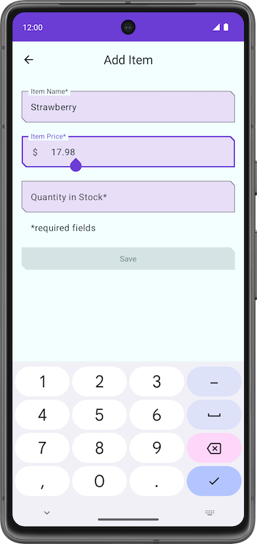 | 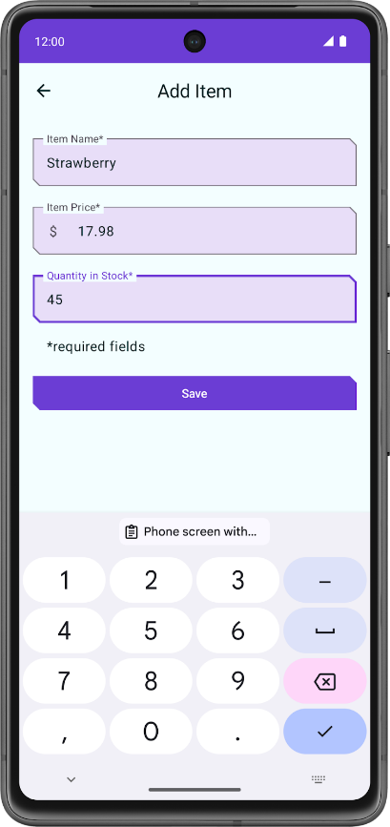

- Take a look at the ItemInputForm() composable function implementation and notice the onValueChange function parameter. You are updating the itemDetails value with the value entered by the user in the text fields. By the time the Save button is enabled, itemUiState.itemDetails has the values that need to be saved.
// No need to copy over, part of the starter code
@Composable
fun ItemEntryBody(
//...
) {
Column(
// ...
) {
ItemInputForm(
itemDetails = itemUiState.itemDetails,
//...
)
//...
}
}

// No need to copy over, part of the starter code
@Composable
fun ItemInputForm(
itemDetails: ItemDetails,
modifier: Modifier = Modifier,
onValueChange: (ItemUiState) -> Unit = {},
enabled: Boolean = true
) {
Column(modifier = modifier.fillMaxWidth(), verticalArrangement = Arrangement.spacedBy(16.dp)) {
OutlinedTextField(
value = itemUiState.name,
onValueChange = { onValueChange(itemDetails.copy(name = it)) },
//...
)
OutlinedTextField(
value = itemUiState.price,
onValueChange = { onValueChange(itemDetails.copy(price = it)) },
//...
)
OutlinedTextField(
value = itemUiState.quantity,
onValueChange = { onValueChange(itemDetails.copy(quantity = it)) },
//...
)
}
}

Add click listener to the Save button
To tie everything together, add a click handler to the Save button. Inside the click handler, you launch a coroutine and call saveItem() to save the data in the Room database.
- In the ItemEntryScreen.kt, inside the ItemEntryScreen composable function, create a val named coroutineScope with the rememberCoroutineScope() composable function.
Note: The rememberCoroutineScope() is a composable function that returns a CoroutineScope bound to the composition where it's called. You can use the rememberCoroutineScope() composable function when you want to launch a coroutine outside of a composable and ensure the coroutine is canceled after the scope leaves the composition. You can use this function when you need to control the lifecycle of coroutines manually, for example, to cancel an animation whenever a user event happens.
import androidx.compose.runtime.rememberCoroutineScope
val coroutineScope = rememberCoroutineScope()

- Update the ItemEntryBody() function call and launch a coroutine inside onSaveClick lambda.
ItemEntryBody(
// ...
onSaveClick = {
coroutineScope.launch {
}
},
modifier = modifier.padding(innerPadding)
)

- Look at the saveItem() function implementation in the ItemEntryViewModel.kt file to check if itemUiState is valid, converting itemUiState to Item type, and inserting it in the database using itemsRepository.insertItem().
// No need to copy over, you have already implemented this as part of the Room implementation
suspend fun saveItem() {
if (validateInput()) {
itemsRepository.insertItem(itemUiState.itemDetails.toItem())
}
}

- In the ItemEntryScreen.kt, inside the ItemEntryScreen composable function, inside the coroutine, call viewModel.saveItem() to save the item in the database.
ItemEntryBody(
// ...
onSaveClick = {
coroutineScope.launch {
viewModel.saveItem()
}
},
//...
)

Notice that you did not use viewModelScope.launch() for saveItem() in the ItemEntryViewModel.kt file, but it is necessary for ItemEntryBody() when you call a repository method. You can only call suspend functions from a coroutine or another suspend function. The function viewModel.saveItem() is a suspend function.
- Build and run your app.
- Tap the + FAB.
- In the Add Item screen, add the item details and tap Save. Notice that tapping the Save button does not close the Add Item screen.
- In the onSaveClick lambda, add a call to navigateBack()after the call to viewModel.saveItem() to navigate back to the previous screen. Your ItemEntryBody() function looks like the following code:
ItemEntryBody(
itemUiState = viewModel.itemUiState,
onItemValueChange = viewModel::updateUiState,
onSaveClick = {
coroutineScope.launch {
viewModel.saveItem()
navigateBack()
}
},
modifier = modifier.padding(innerPadding)
)

- Run the app again and perform the same steps to enter and save the data. Notice that this time, the app navigates back to the Inventory screen.
This action saves the data, but you cannot see the inventory data in the app. In the next task, you use the Database Inspector to view the data you saved.

10. View the database content using Database Inspector
The Database Inspector lets you inspect, query, and modify your app's databases while your app runs. This feature is especially useful for database debugging. The Database Inspector works with plain SQLite and with libraries built on top of SQLite, such as Room. Database Inspector works best on emulators/devices running API level 26.
Note: The Database Inspector only works with the SQLite library included in the Android operating system on API level 26 and higher. It doesn't work with other SQLite libraries that you bundle with your app.
- Run your app on an emulator or connected device running API level 26 or higher, if you have not done so already.
- In Android Studio, select View > Tool Windows > App Inspection from the menu bar.
- Select the Database Inspector tab.
- In the Database Inspector pane, select the com.example.inventory from the dropdown menu if it is not already selected. The item_database in the Inventory app appears in the Databases pane.
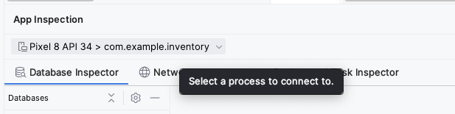
- Expand the node for the item_database in the Databases pane and select Item to inspect. If your Databases pane is empty, use your emulator to add some items to the database using the Add Item screen.
- Check the Live updates checkbox in the Database Inspector to automatically update the data it presents as you interact with your running app in the emulator or device.
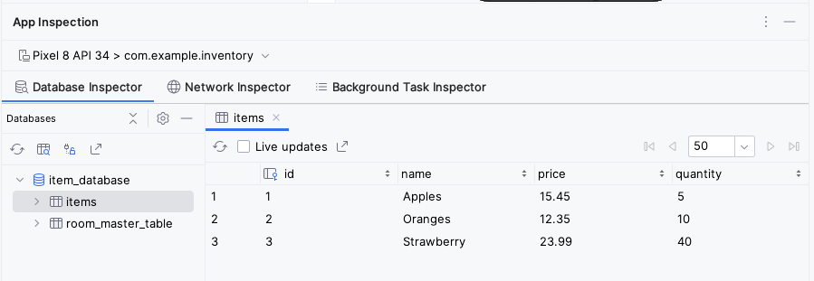
Congratulations! You created an app that can persist data using Room. In the next codelab, you will add a lazyColumn to your app to display the items on the database, and add new features to the app, like the ability to delete and update the entities. See you there!

11. Get the solution code
The solution code for this codelab is in the GitHub repo. To download the code for the finished codelab, use the following git commands:
$ git clone https://github.com/google-developer-training/basic-android-kotlin-compose-training-inventory-app.git
$ cd basic-android-kotlin-compose-training-inventory-app
$ git checkout room

Alternatively, you can download the repository as a zip file, unzip it, and open it in Android Studio.
https://github.com/google-developer-training/basic-android-kotlin-compose-training-inventory-app/archive/refs/heads/room.zip
Note: The solution code is in the room branch of the downloaded repository.
If you want to see the solution code for this codelab, view it on GitHub.
https://github.com/google-developer-training/basic-android-kotlin-compose-training-inventory-app/tree/room

12. Summary
- Define your tables as data classes annotated with @Entity. Define properties annotated with @ColumnInfo as columns in the tables.
- Define a data access object (DAO) as an interface annotated with @Dao. The DAO maps Kotlin functions to database queries.
- Use annotations to define @Insert, @Delete, and @Update functions.
- Use the @Query annotation with an SQLite query string as a parameter for any other queries.
- Use Database Inspector to view the data saved in the Android SQLite database.

13. Learn more
Android Developer Documentation
Save data in a local database using Room | https://developer.android.com/training/data-storage/room
androidx.room | https://developer.android.com/reference/androidx/room/package-summary
Debug your database with the Database Inspector | https://developer.android.com/studio/inspect/database

Blog posts
7 Pro-tips for Room | https://medium.com/androiddevelopers/7-pro-tips-for-room-fbadea4bfbd1
The one and only object. Kotlin Vocabulary | https://medium.com/androiddevelopers/the-one-and-only-object-5dfd2cf7ab9b

Videos
Kotlin: Using Room Kotlin APIs | https://www.youtube.com/watch?v=vsDkhRTMdA0
Database Inspector | https://www.youtube.com/watch?v=UMc7Tu0nKYQ

Other documentation and articles
Singleton pattern | https://en.wikipedia.org/wiki/Singleton_pattern
Companion objects | https://kotlinlang.org/docs/object-declarations.html#companion-objects
SQLite Tutorial - An Easy Way to Master SQLite Fast | https://www.sqlitetutorial.net/

